 **Paper Assignment**

***Submitted by : Sardar Munaqib***

***Submitted to : Sir Shakir Rasheed Khan***

***Subject : Introduction To Software Engineering***

**Question no 01: Describe the Waterfall model? Lists the stages of waterfall model for software development and list three advantages and disadvantages?**

**Answer: Waterfall Model:**

# The waterfall model is a sequential design approach in which development is seen as flowing steadily downwards (like a waterfall) through the phases of conception, initiation, analysis, design, construction, testing, deployment and maintenance.

**Stages of Waterfall Model for software development :**

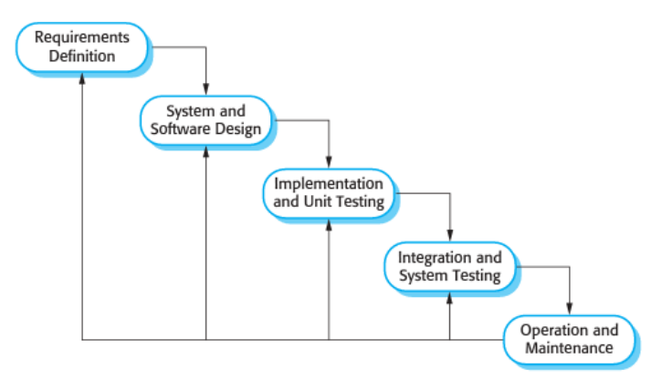

**Following are the stages of the Waterfall model.**

# System Requirements:

 All possible requirements of the system to be developed are captured in this phase and documented in a requirement specification document.

1. System Analysis:

The system specifications are analyzed to generate product models and business logic that will guide production.

# System Design:

The requirement specifications from the first phase are studied in this phase and DDS (Design Document Specification) is made which is helpful in understanding technical design requirements.

# System Implementation:

The development is being started and the coding of the project is done in this phase according to the given requirements using Models and different logic.

# System Testing:

For quality assurance, different testing is performed on the product which is the output of the requirements. Unit and Beta testing take place. This may cause a forced repeat of the coding stage for debugging.

# System Deployment:

The product or application is deemed fully functional and is deployed to a live environment.

# System Maintenance:

Corrective, adaptive and perfective maintenance is carried out indefinitely to improve, update and enhance the final product.

# **Advantages And Disadvantages:**

# Advantages:

1. Reinforces good coding habits to define before design and then code.

2. Allows for early design or specification changes to be made easily.

3. Clearly defines milestones and deadlines.

# Disadvantages:

1. Delays testing until the end of the development life cycle.

2. Does not consider error correction.

3. Does not handle requests for changes, scope adjustments, or updates well.

**Question: no :02 lists the stages of software development life cycle (SDLC)? Describe each stage in one phrase each?**

**Answer:** The software development life cycle (SDLC) is a framework defining tasks performed at each step in the software development process. SDLC is a process used by the software industry to design, develop and test high-quality software. The SDLC aims to produce high-quality software that meets or exceeds customer expectations and reaches completion within times and cost estimates.

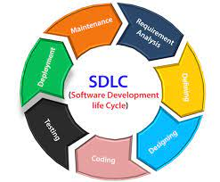

***Following are the phases of SDLC (software development life cycle).***

1. **Planning and Requirement Analysis:**

It is the most important and fundamental step in SDLC. It is performed by senior members of the organization with the information given by the customer. Planning for the quality assurance requirements and identification of the risks.

1. **Defining Requirements:**

In this step, SRS (Software Requirement Specification) document is made on the information and input given by the customer. SRS document includes all requirements for the product.

1. **System Design:**

On the basis of the SRS document DDS (Design Document Specification) is made in which features and operations performed by the system are described. DDS also involves business rules and project diagrams.

1. **Implementation:**

In this phase development is start on the project source code is generated according to DDS.

1. **Testing the Product:**

Testing is performed on the Project. Various testing such as beta testing and high and low-level testing is performed on the project. Most testing is performed by the end-user or customer.

1. **Deployment**:

In this, the product is made operational or deployed in a live environment. The product takes real-world data from the different operations on it and gives output.

1. **Maintenance:**

changes corrections, additions, and more things are done on the product according to customer needs.

# **Question:no:03 User Requirement and System Requirements for the library:**

# **Answer**: User Requirement:

users must be able to access the system and have the necessary permissions to perform their tasks and view book names and can see their dues and get information and news about the library.

# System Requirement:

1. **Functional Requirement:**

**login:**

There is a login that must be available for users and librarians. all have to log in before performing or entering the system and the user and librarian must have a unique ID and password.

**Regin:**

If there is a new user comes then the user must have to enter their name, CNIC, address, Phone number and other information to make his account or membership.

**Search:**

There is a search function that must be available for the user or customer (in limitation) and librarians to check whether the search book is available or not or is borrowed or not. The book is searched by the ISBN no which must be assigned to all books present in the library. The borrowed book customer shell was only seen by the librarians only.

**Pay Dues:**

The user can pay their dues online and the librarian shall see the dues. Their shell be a notification generated for the user and librarian that the user had paid his dues and if the user had not paid his dues or the last date to pay dues then there will be a notification generated to pay your dues.

1. **Non-Functional Requirement:**

**1-**The system shell remains operational from Mon-Fri **(9.00 am to 2.00 pm).**

**2-**The system should be simple enough so everyone can understand it easily and get relevant information without any special training. The system should be available in different languages according to the given requirements **(English and Urdu etc.).**

**3-**The system shall be easily maintainable. There should be enough flexibility or space in the system so you can add more functionalities to the system in the future according to the requirements.

**4-**The system should run on windows/Linux and apple OS (operating system).

**5-**The front hand shall be written in Angular while the back end shall be written in JavaScript

**Question:no:04: Draw use-case diagram and Domain Model?**

**Answer:**  ***University* *Management* *System***

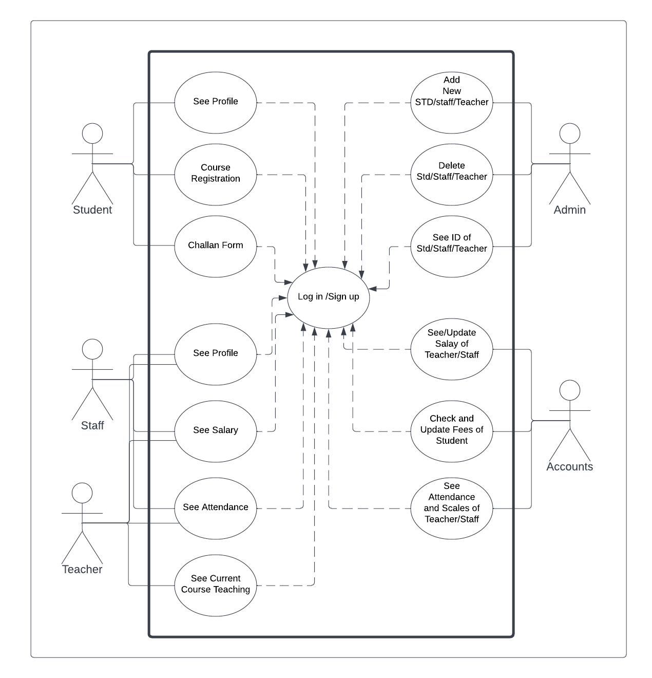

*Domain Model for* ***University Management System***

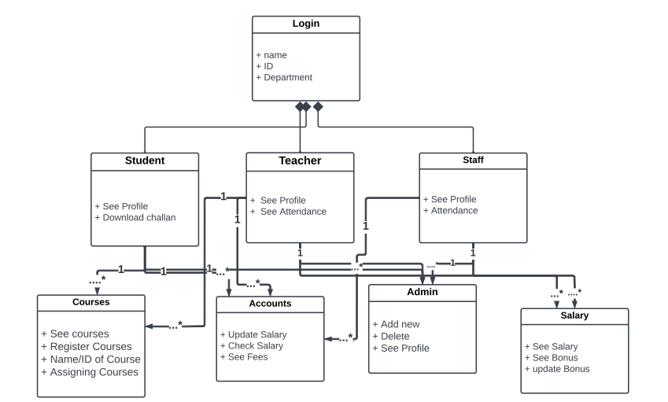

**Question : no : 05: Write the non-functional requirements for following two projects:**

**Answer: Bike Racing Game:**

**. High graphics:**

The game must have high-quality graphics which must attract people or gamers. The high-quality graphics give the game a realistic look.

* **High performance:**

The speed of the game becomes high as the gamers reach the upper level of the game and the game must give its best performance.

* **Security:**

The account of the gamer must be protected and secure so no one easily can hack or may access its account easily. There should be a password and ID for all users who are playing the game.

* **Usability:**

The game must be developed according to the gamer requirements and market survey so that more people are interested in the game.

***Online Banking System:***

* **Security:**

The personal information of a user and their account must be secure no one can access the user account except the user and admin.

* **Operational:**

The server should not be down during working hours (9.00 am – 2.00 pm) and also there is a backup available for it.

* **Performance:**

The system must give its best performance so users can easily access it.

* **Interoperability**:

They can take or transfer the money to the other system without any risk involved and when say to the system. There must be a QR code and password for transferring or accepting the money and a message given to the user’s mobile number after transferring and accepting money.

* **Regulation:**

The system must work according to the rules and regulations were given by the authority and also registered in a particular authority so that there will be a belief of user.

**THAT’S** **END**